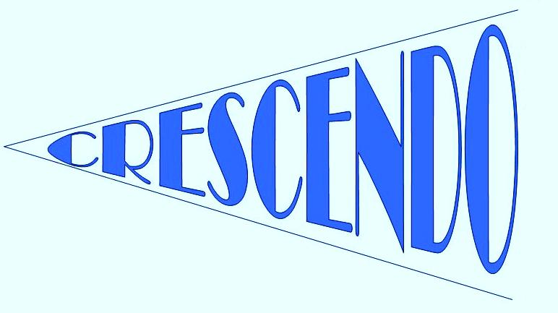

●●●

**MEET THE TEAM**

●●●

♫ **Finn Ros** ♫

♫ **Claire Huntington** ♫

♫ **Adrian Cleverley** ♫

♫ **Nicole Wyatt** ♫

See our website for short biographies of each of us: www.crescendolondon.com

[www.crescendolondon.com](http://www.crescendolondon.com)

[www.facebook.com/crescendomusicclasses](http://www.facebook.com/crescendomusicclasses)

**CRESCENDO NEWS**

♫ **Welcome!**

I’d like to welcome you all to the second year of Crescendo and to our very first newsletter! I will be sending you a copy at the beginning of each term, keeping you up-to-date with events, exciting news and important dates for your diary. There are quite a few changes occurring this year, but I am very much looking forward to welcoming back familiar faces as well as those joining us for the first time!

♫ **Changes in staff…**

Next is some sad news. After a brilliant first year, Hannah has decided to concentrate on her music career outside of teaching. She has loved her time with Crescendo and she will be missed, but we wish her the best of luck! Following on from this, I am very excited to introduce three new members to the team – Nicole, Claire and Adrian. Claire bought her cello in before Christmas and some of you may remember Adrian bringing in his trombone at the end of last term! Nicole has lots of experience teaching music in the EYFS!

I am hoping to bring in lots of visitors this year, to give your child the opportunity to find out about lots of different instruments and styles of music. In order to keep up to date with what is happening each week, I have created a blog on the website – it will be updated regularly to keep you informed.

See you all on the 22nd September! Enjoy the rest of your summer. ***Finn*** ♫

***“Crescendo classes are individually created music sessions for the Early Years; children aged 0-6.5 years old. The sessions aim to introduce your child to music through singing and the use of instruments incorporating games, rhythm activities and group percussion.”***

***NEWSLETTER***

***SEPTEMBER 2012***

** We’re on Facebook!**

**Find the Crescendo Music page on Facebook for updates, pictures and links. I will, of course, not be sharing any photographs of children without explicit permission…**

**Please share the page with friends and anyone you think might be interested.**

**www.facebook.com/crescendomusicclasses**

CLASSES/TIMES/AUTUMN HALF-TERM DATES:

**Butterflies 1:** 9.45 – 10.25

**Caterpillars/Cocoons:** 10.30 – 11.10

**Butterflies 2:** 11.15 – 11.55

**The theme for this half-term is:**

C:\Users\Finn\AppData\Local\Microsoft\Windows\Temporary Internet Files\Content.IE5\3EMOBXGD\MC900281692[1].wmf**On 20th October, we will be having a Teddy Bear’s picnic to finish off our theme of Animals! Please allow your child to bring in a teddy/toy to participate.**

**Half-term dates**

**September**  22, 29

**October** 6, 13, 20

*Half term 27 October & 3 November (no Saturday Centre)*

**The new half-term will start back on the** 10th November.



Nearest tube: *Tufnell Park* or *Kentish Town*. Nearest overground: *Gospel Oak* or *Hampstead Heath.* Nearest buses: *C2; C11; 214*

**Animals**

**CONTACT AND BOOKING INFORMATION**:

Email Crescendo directly at: [crescendouk@gmail.com](mailto:crescendouk@gmail.com)

or look at the website for up to date information: [**www.crescendolondon.com**](http://www.crescendolondon.com)

You can also like us on facebook for updates about classes, events and information: www.facebook.com/crescendomusicclasses

**Booking Information**: Camden Music Service. Tel: 020 7974 7239. E-mail: [camdenmusic@camden.gov.uk](mailto:camdenmusic@camden.gov.uk). Please include the name and age of your child in the email, as well as a number for us to contact you.

**Visiting us:** All classes held at: *La Sainte Union Catholic School, Highgate Road, NW5 1RP*

