F F
A Keelie Makolay, mo paco meeno sway
F F
Yeah, yeah, mo paco meeno sway.
F F
A Keelie Makolay, mo paco meeno sway
F F
Yeah, yeah, mo paco meeno sway.

* * * * *
Mo paco meeno sway,
* * * * *
Mo paco meeno sway,
* * * * *
Mo paco meeno sway,
* * * * *
O mo paco meeno sway.
F * * * *
Mo paco meeno sway,
* * * F
Mo paco meeno sway,
F * * * *
Mo paco meeno sway,
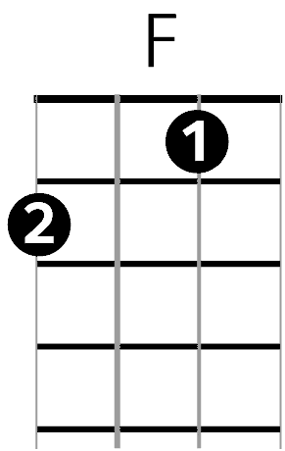
* * * * *
O mo paco meeno sway.

London’s Burning
F F
London’s Burning, London’s burning,
C F C F
Fetch the engines, fetch the engines,
C C C C
Fire! Fire! Fire! Fire!
C F C F
Pour on water, pour on water.

