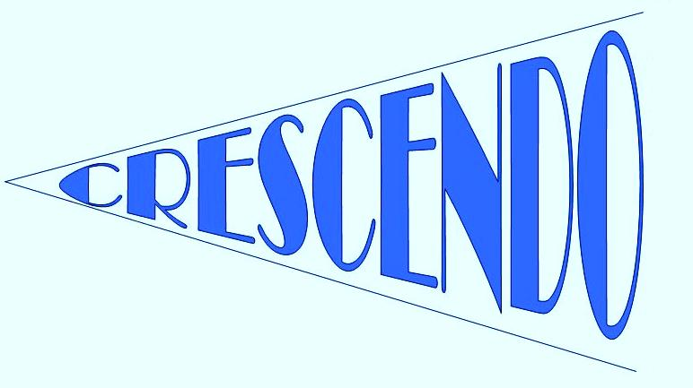

**CRESCENDO NEWS**

♫ **Welcome!**

Welcome to the Spring newsletter. I hope you are all having a relaxing Christmas break and are looking forward to another fun Crescendo term.

♫ **We are moving…**

The first exciting piece of news is that Crescendo (and Camjam) are changing venue! The classes will now be based at: Brecknock Primary School. There is a map and more information provided overleaf, as well as on the Crescendo website.

♫ **Questionnaire…**

I have attached a short questionnaire to find out about the music that your child participates in at home. I feel that it will help with planning and provision within the sessions to find out what sort of music and singing experiences your child has had.

The first theme is stories – I am very much looking forward to The Gruffalo; should be fun!

See you all on the 12th November! Merry Christmas and a happy new year

***Finn*** ♫

●●●

**MEET THE TEAM**

●●●

♫ I was lucky enough to teach alongside Nicole and Claire for the first term. They will be returning to Crescendo at points in this coming term, alongside new teachers who will be coming in to introduce their instruments. ♫

See our website for short biographies of each of the crescendo teachers: www.crescendolondon.com

@crescendouk

[www.crescendolondon.com](http://www.crescendolondon.com)

[www.facebook.com/crescendomusicclasses](http://www.facebook.com/crescendomusicclasses)

***“Crescendo classes are individually created music sessions for the Early Years; children aged 0-6.5 years old. The sessions aim to introduce your child to music through singing and the use of instruments incorporating games, rhythm activities and group percussion.”***

***NEWSLETTER***

***Spring***

***2012***

** We’re on Facebook!**

**Find the Crescendo Music page on Facebook for updates, pictures and links. I will, of course, not be sharing any photographs of children without explicit permission…**

**Please like us and share the page with friends and anyone you think might be interested.**

[**www.facebook.com/crescendomusicclasses**](http://www.facebook.com/crescendomusicclasses)

** We are also on Twitter: @crescendouk**

CLASSES/TIMES/AUTUMN HALF-TERM DATES:

**Butterflies 1:** 9.45 – 10.25 **The theme for this half-term is:**

**Caterpillars/Cocoons:** 10.30 – 11.10

**Butterflies 2:** 11.15 – 11.55

**C:\Users\Finn\AppData\Local\Microsoft\Windows\Temporary Internet Files\Content.IE5\YPABJMK2\MC900390846[1].wmf**

**Memo about classes:**

There has been some confusion and concern over ages for classes and when children are old enough to move into the next class up. Here are the guidelines to clear this up; children move classes according to *age* not ability. At this young age, it is important for children to build up their friendships as well as musical experience, so we keep age groups together.

*Caterpillars*/*Cocoons*: Move up to *Butterflies* 2 at the start of the term **after** they turn 4 years old.

*Butterflies* 2: move up to *Butterflies* 1 at the start of term **after** they turn 5 years old.

*Butterflies* 1: move up to *Foundation* at the start of term **after** they turn 6 years old.



**Stories**

Tube: *Tufnell Park / Kentish Town.*

Nearest Overground: *Caledonian Road & Barnsbury*

Buses: *390*

**Half-term dates**

**January**  12, 19, 26

**February** 2, 9

*Half term 16 February & 23 February (no Saturday Centre)*

**March** 2, 9, 16, 23

**CONTACT AND BOOKING INFORMATION**:

Phone Crescendo directly on: 07827931824, email: [crescendouk@gmail.com](mailto:crescendouk@gmail.com) or look at the website for up to date information: **www.crescendolondon.com**

**Booking Information**: Camden Music Service. Tel: 020 7974 7239. E-mail: [camdenmusic@camden.gov.uk](mailto:camdenmusic@camden.gov.uk). Please include the name and age of your child in the email, as well as a number for us to contact you.

**Visiting Us:** **We are moving to a new venue:** Brecknock Primary School, Cliff Villas, London, NW1 9AL