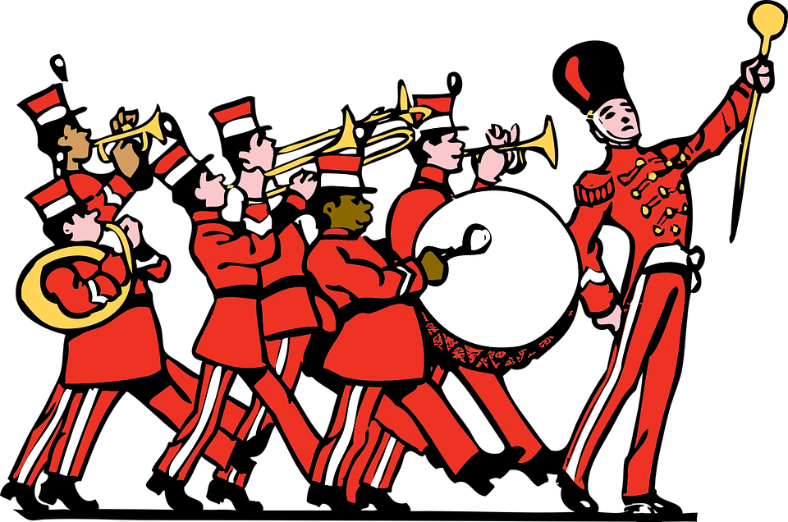

The Grand Old Duke of York

Oh, the Grand Old Duke of York,
He had ten thousand men,
He marched them up to the top of the hill
And he marched them down again.

And when they were up, they were up!
And when they were down, they were down!
And when they were only half-way up,
They were neither up nor down!

He marched them to the left!
He marched them to the right!
He marched them all around the place,
Oh what a silly sight!

I recently got introduced to this 3rd verse – could be quite fun to sing, especially whilst marching around!!

